COS225 Generic Stack as Linked List

Previously, an array was used to implement the Stack interface. Arrays offer fast retrieval times due to the contiguous storage of the data. The subscript operator [ ] needs only do a simple math calculation given the base address of the array and index to access the desired element to access it.

Another common storage pattern is the linked list. Linked lists store data in nodes, where each node contains the element and a reference to the next node in sequence. The first node is called the head and the last node is the tail.

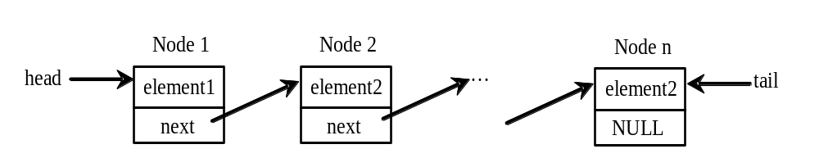

Advantages:
- Memory can be allocated and released as needed. Arrays are sometimes oversized with unused elements. Resizing a large array is a slow process.
- Some algorithms are faster than their array counterparts. For example, in order to insert an item into a sorted array, many elements have to be shuffled up to make a hole for the new item. In a linked list, a new node can be inserted with a few steps.
- Flexible nonlinear data structures can be created with nodes that utilize multiple references. Examples include the tree and the graph.

Disadvantages:
- Each node has the overhead of reference fields. This could add up to more space than used for an array.
- Some algorithms are slower than their array counterparts. For example, a sequential search is faster in an array than a list due to the overhead of processing the reference links.

A LinearNode Class:
A node is represented in its own class as it contains multiple data fields and a few simple methods for construction and destruction. A generic class is used since the element can be of any data type.

public class LinearNode<T> {

private T element; // data element
private LinearNode<T> next; // reference to next node

public LinearNode ( ) { // POST: empty node
element = null;
next = null; }

public LinearNode (T element ) { // POST: node with element set
this.element = element;
next = null; }

public T getElement() { // POST: return element
return element; }

public void setElement(T element) { // POST: set element
this.element = element; }

public LinearNode<T> getNext() { // POST: get next reference
return next; }

public void setNext(LinearNode<T> next) { // POST: set next reference
this.next = next; }
}

Create three nodes of strings and manually chain them together to create a singly linked list. This simple type of list contains only forward links to successive nodes.

Step 1: Declare references to the head node. Since this list is currently empty, this pointer stores null.

LinearNode<String> head = null;

Step 2: Create the first node and insert it to the list:

head = new LinearNode<String> ("Chicago");

head | element: "Chicago"  next: null

Step 3: Create the second node and insert it to the head of the list:

LinearNode<String> temp = new LinearNode<String> ("Denver");
temp.setNext(head);
head = temp;

temp | element: "Denver"  next:

head | element: "Chicago"  next: null

Step 4: Create the third node and insert it to the head of the list:

temp = new LinearNode<String> ("Miami");
temp.setNext(head);
head = temp;

temp | element: "Miami"  next:

head | element: "Denver"  next: |  | element: "Chicago"  next: null

List Traversal:
Singly linked lists can only be traversed in one direction, from the head node to the tail node. Unlike arrays there is no direct access to any particular element. The code below performs a list traversal, displaying the element of each node.

LinearNode<String> current = head; // start with the first node
while (current != null) // while more nodes to visit…
{
System.out.println (current.getElement( )); // display the element
current = current.getNext( ); // set current to next node
}

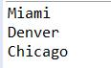

Implementing the Stack interface:
The Stack interface models an abstract class, removed from implementation details.

public interface Stack<T> {

public void push (T element); // POST: add element to top of stack
public T pop ( ); // PRE: stack is not empty
// POST: remove and return top element
public T peek ( ); // PRE: stack is not empty
// POST: return top element
public boolean isEmpty( ); // POST: return true if stack is empty, else false
public int size ( ); // POST: return number of elements in stack
}

This stack version implements the interface using a singly linked list.

public class LinkedStack<T> implements Stack<T> {

private LinearNode<T> top; // reference to top node of stack (head)
private int count; // number of items in stack (# of nodes)

public LinkedStack ( ) { // POST: empty stack
top = null; count = 0; }

public void push (T element) { // POST: add element to top of stack
LinearNode<T> temp = new LinearNode<T> (element); // make new node
temp.setNext(top); // new node points to current top (head)
top = temp; // new node becomes the top (head)
count++; }

public T pop ( ) throws EmptyCollectionException // PRE: stack is not empty
// POST: remove and return top element
{ if (isEmpty( )) throw new EmptyCollectionException ( );
T result = top.getElement(); // save element in top (head) node
top = top.getNext( ); // assign top to next node
count--; // garbage collector reclaims old top node
return result; }

public T peek ( ) throws EmptyCollectionException // PRE: stack is not empty
// POST: return top element
{ if (isEmpty( )) throw new EmptyCollectionException ( );
return top.getElement( ); }

public boolean isEmpty( ) // POST: return true if stack is empty
{ return count==0; }

public int size( ) // POST: return number of elements
{ return count; }
}

Example: Using a stack to implement
Code below tests the stack.

public static void main(String[ ] args) {
LinkedStack<String> s = new LinkedStack<String> ( );
s.push("Chicago");
s.push("Denver");
s.push("Miami");
s.pop( );
System.out.println ("There are " + s.size( ) + " cities.");
System.out.println ("City at top is " + s.peek( ));
while (!s.isEmpty( ))
System.out.println ("City name: " + s.pop( ));
}

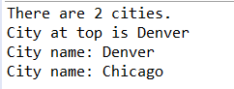

Java Stack:
Java offers a Stack class in the following class hierarchy

java.lang.Object
java.util.AbstractCollection<T>
java.util.AbstractList<T>
java.util.Vector<T>
java.util.Stack<T>

Stack extends the Vector class with five methods that enable a vector to be treated as a LIFO stack.

boolean isEmpty( ) Test if stack is empty
T peek ( ) Returns reference to top object
T pop ( ) Returns reference to top object and removes it
T push (T) Returns reference to object and adds to top of stack
int search (T) Returns index of first occurence of argument on on stack;
index is 1-based, return -1 if not found, uses object's equals method

The Vector class is similar to the ArrayList class in that it uses an array to store elements. Differences between the two classes are shown below.

ArrayList | Vector
1) ArrayList is not synchronized. | Vector is synchronized.
2) ArrayList increments 50% of current array size if number of element exceeds from its capacity. | Vector increments 100% means doubles the array size if total number of element exceeds than its capacity.
3) ArrayList is not a legacy class, it is introduced in JDK 1.2. | Vector is a legacy class.
4) ArrayList is fast because it is non-synchronized. | Vector is slow because it is synchronized i.e. in multithreading environment, it will hold the other threads in runnable or non-runnable state until current thread releases the lock of object.
5) ArrayList uses Iterator interface to traverse the elements. | Vector uses Enumeration interface to traverse the elements. But it can use Iterator also.

Note that Java Stack does not force LIFO behavior, it enables it. Because Stack inherits from Vector a Stack object has access to all public methods in Vector, including internal insertion or removal. When reading about Java Stack, you may see comments that use of a class implementing Deque interface is preferrable and faster. We will discuss deques (double ended queues) in a later lecture.

The program below uses a stack to evaluate an expression, such as one entered into a calculator. For example, the expression: (1 + 2) * 4 – 3 yields 9. The problem uses one stack for holding operands and another for holding operators. Operands and operators are pushed onto their stacks. When an operator is popped and processed, it is applied to two popped operands. The results is pushed back onto the operands stack.

Issues involve the handling of parentesized expressions and order of operations, performing * and / prior to + and -.

Phase 1: Scan the expression, one token at a time.
1.1 If the item is an operand, push it to operand stack
1.2 If the item is + or –, process all operators in operators stack and then push operator
1.3 If the item is * or /, process * or / operators in operators stack and then push operator
1.4 If the item is (, push to operator stack
1.5 If the item is ), repeatedly process operators until encountering (

Phase 2: Clear the stacks
- Repeatedly process the operators until stack is empty

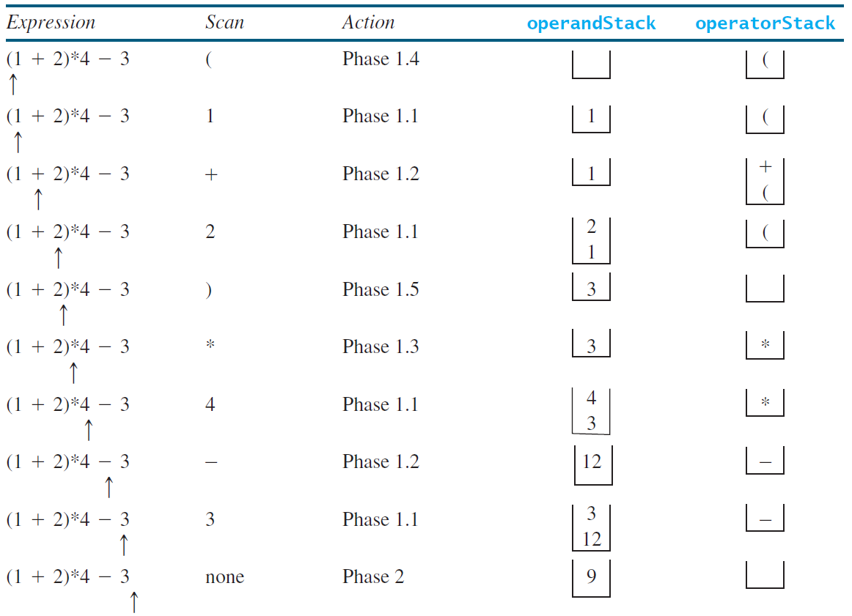

This program is run from the console, allowing the user to enter the expression as an argument to the main method. The main method args parameter is a String array.

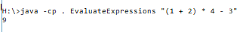

public class EvaluateExpressions {

public static void main(String[ ] args) {
if (args.length != 1)
{ System.out.println("Usage: java EvaluateExpression \"expression\"");
System.exit(1);
}
System.out.println(evaluateExpression (args[0]));
}

// POST: return expression result
public static int evaluateExpression (String expression)
{
LinkedStack<Integer> operands = new LinkedStack<Integer> ( );
LinkedStack<Character> ops = new LinkedStack<Character> ( );
expression = insertBlanks(expression);
String [ ] tokens = expression.split(" ");

for (String token: tokens)
{ if (token.length() == 0)
continue;
else if (token.charAt(0) == '+' || token.charAt(0) == '-')
{
while (!ops.isEmpty() && (ops.peek() == '+' || ops.peek() == '-' ||
ops.peek() == '*' || ops.peek() == '/'))
processOperator (operands, ops);
ops.push(token.charAt(0));
}
else if (token.charAt(0) == '*' || token.charAt(0) == '/')
{
while (!ops.isEmpty() && (ops.peek() == '*' || ops.peek() == '/'))
processOperator(operands, ops);
ops.push(token.charAt(0));
}
else if (token.trim().charAt(0) == '(')
ops.push('(');
else if (token.trim().charAt(0) == ')')
{ while (ops.peek() != '(')
processOperator(operands, ops);
ops.pop();
}
else
operands.push(new Integer(token));
}

while (!ops.isEmpty())
{ processOperator(operands, ops);
}
return operands.pop();
}

public static void processOperator (Stack<Integer> operands, Stack<Character> ops)
{
char op = ops.pop( );
int op1 = operands.pop( );
int op2 = operands.pop( );
if (op == '+') operands.push(op2+op1);
else if (op == '-') operands.push(op2-op1);
else if (op == '*') operands.push(op2*op1);
else if (op == '/') operands.push(op2/op1);
}

public static String insertBlanks(String s)
{ String result = "";
for (int k = 0; k < s.length(); k++)
{
if (s.charAt(k) == '(' || s.charAt(k) == ')' || s.charAt(k) == '+' ||
s.charAt(k) == '-' || s.charAt(k) == '*' || s.charAt(k) == '/')
result += " " + s.charAt(k) + " ";
else
result += s.charAt(k);
}
return result;
}
}

